# **Lab # 12: CRUD Operations using PHP**

**Using Databases**

To use a database or query some table in a database, following are the typical steps to do;

1. Create a connection to the database.

2. If connection successful, write a query statement.

3. Parse this query using connection handler and query statement (note that this step is specific to

ORACLE only).

4. Execute query.

5. Fetch the result set generated by the query.

6. Loop over the result set and display data using html and PHP.

**4.1 Step 1 (Create a Connection to the database)**

In PHP, this is done with the [db type]_connect()

function. [db type]_connect(servername, username, password);

**Parameter Description**

servername Specifies the server to connect to.

username Specifies the username to log in with. Default value is the name of the user that owns the database server

password Specifies the password to log in with.

**Note:** oracle 11g servername can be found in: (oraclebase)\app\Your_username\product\11.2.0\dbhome_1\NETWORK\ADMIN\ tnsnames.ora

6

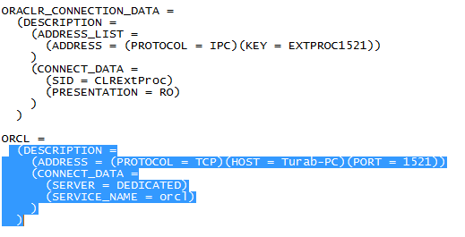

**Example 4.1**

Create a web page (blank page) with the name as dbcon.php in your ‘htdocs’

directory.

Type the following code in the file and run it in the browser.

<html>

<body>

<?php

// example 2.1 ..creating a database connection

$db_sid = "(DESCRIPTION = (ADDRESS_LIST = (ADDRESS = (PROTOCOL = TCP)(HOST = Turab-PC)(PORT = 1521)) ) (CONNECT_DATA = (SID = orcl) ) )";

$db_user = "scott";

$db_pass = "1234";

$con = oci_connect($db_user,$db_pass,$db_sid);

if($con)

{

}

else

{

}

?>

</body>

</html>

echo "connection successful.";

die('Could not connect: ');

In this example we store the connection in a variable ($con) for later use in the script. The "die" part will be executed if the connection fails.

So now if the connection is successful, we’ll now proceed to query the EMP table as follows;

**4.2 Step 2 (Write a query) Example 4.2**

Write the bold line in your file as follows;

<html>

<body>

<?php

// example 2.1 ..creating a database connection

$db_sid = "(DESCRIPTION = (ADDRESS_LIST = (ADDRESS = (PROTOCOL = TCP)(HOST = Turab-PC)(PORT = 1521)) ) (CONNECT_DATA = (SID = orcl) ) )";

$db_user = "scott";

$db_pass = "1234";

**Task 1:** Create PHP file (insertion.php) that takes input from user as shown in Fig. 1. User have to Enter Data in the Text fields in order to Insert Employee Name, Number, Job, Salary and so on. When user click on the “Save to Database” button, all the data should be inserted into Empolyees table of HR User. And **“Insertion Successful”** Message should be displayed on the same file.

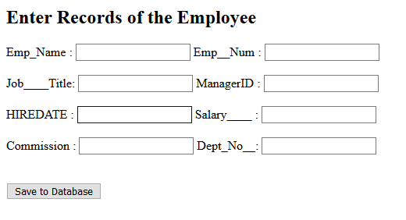

**Task 2:** Create PHP file (update.php) as shown in ***Fig. 2.*** that search the record on the basis of Employee_ID enter by the user. When user Click on the ***Search the Record*** button, all data should be Display on the respective Fields as shown in ***Fig. 3***. User edit the Record as text fields are editable then press ***Update the Record*** Button. Record should be updated in the Database. And “Record Updated” Message should be display on the same file.

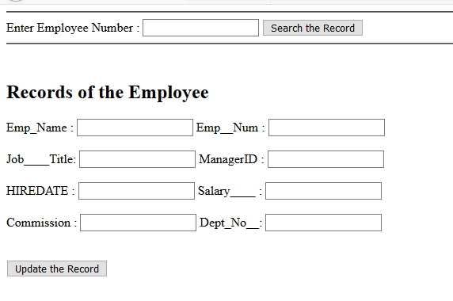

**Fig. 2**

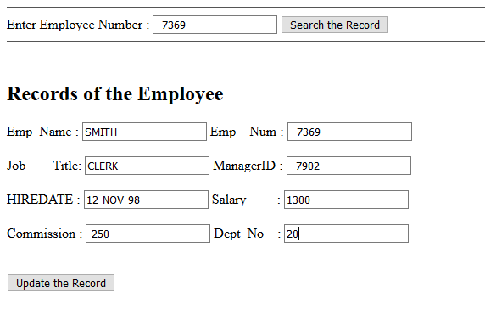

**Fig. 3**

**TASK 3:** Create PHP file (del_info.php) which receive Employee_ID from user and delete the record from the database on basis of received Employee_ID and output the following message “Record Deleted “on the Screen after deletion.